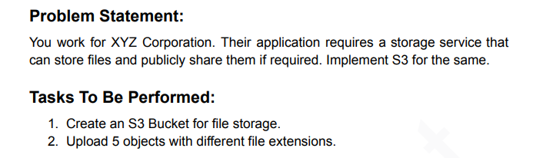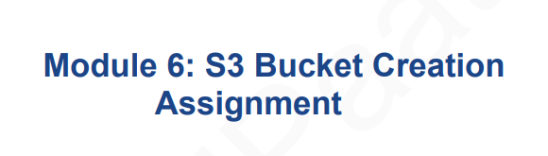

1. Creating S3 Bucket

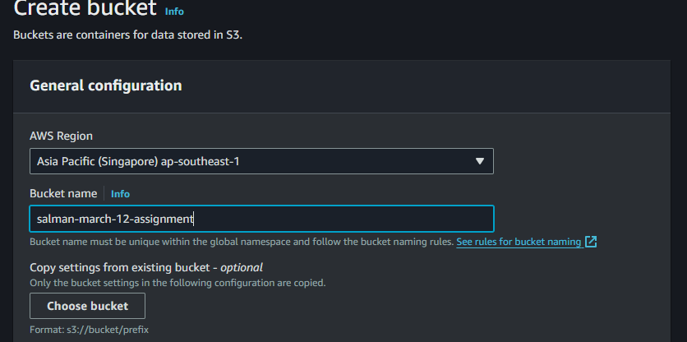

1. Click Create

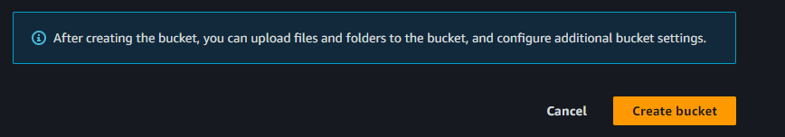

1. 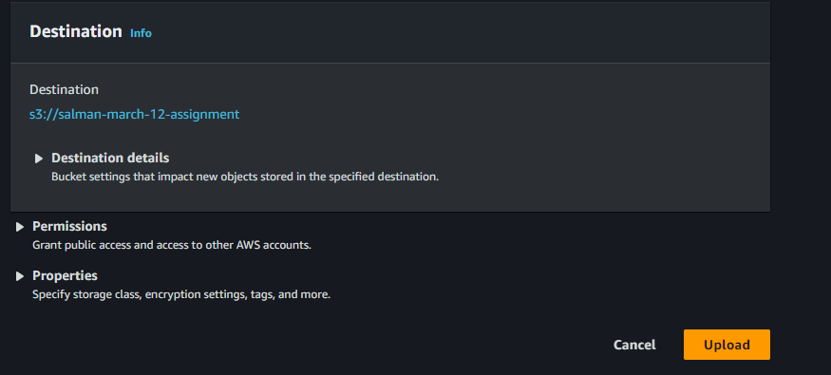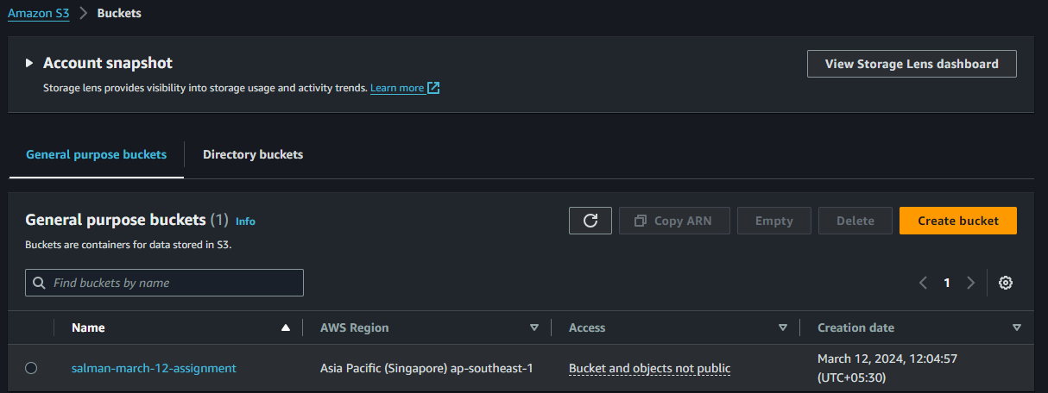Created Successfully

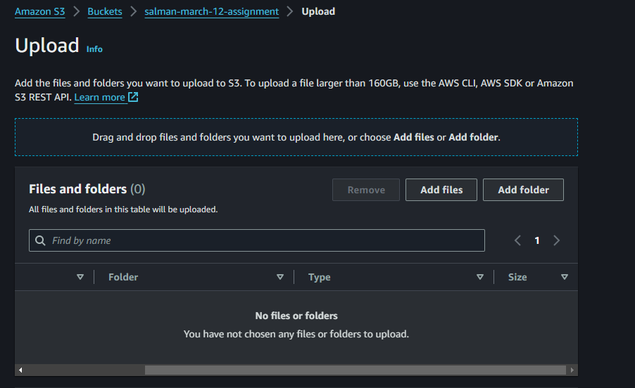3. Click Add Files

1. UploadedSuccessfully

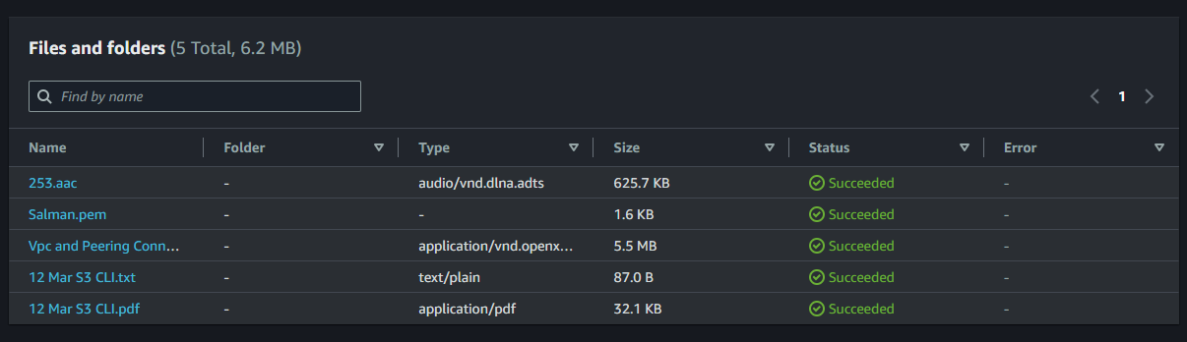

1. Now We Can See 5 Different File Extensions and the Assignment Task 1 Finshed

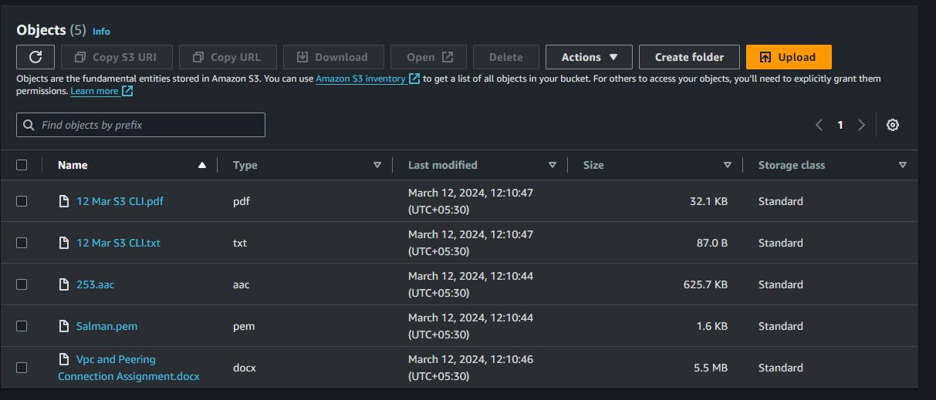

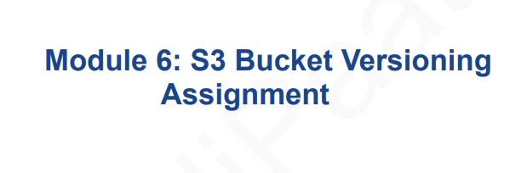

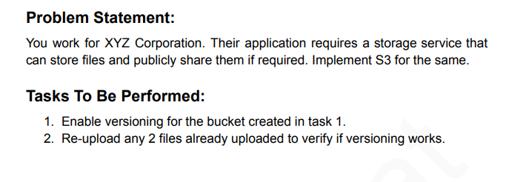

1. Now Need to Enable Versioning For Bucket (Task-2 Continue) and Go to Properties we find

Bucket Versioning and Click Edit

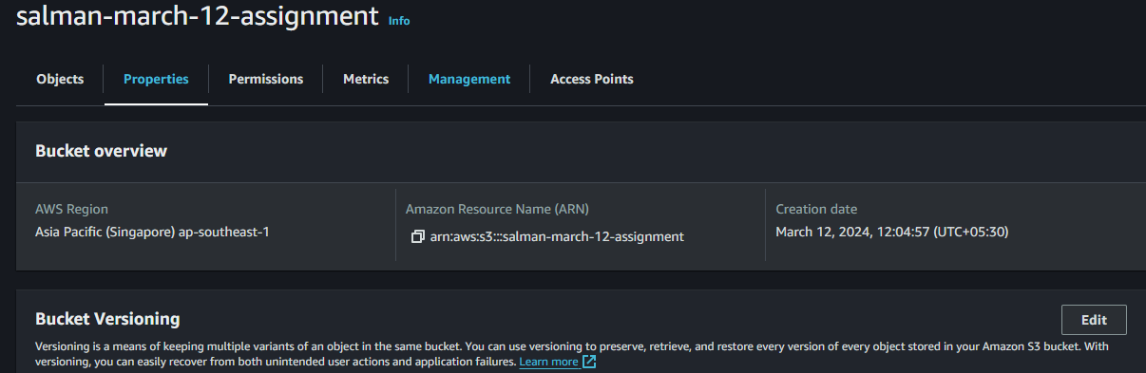

1. Select Suspend to Enable and Click Save Changes

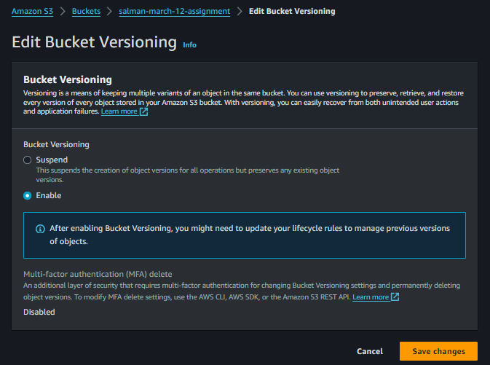

1. 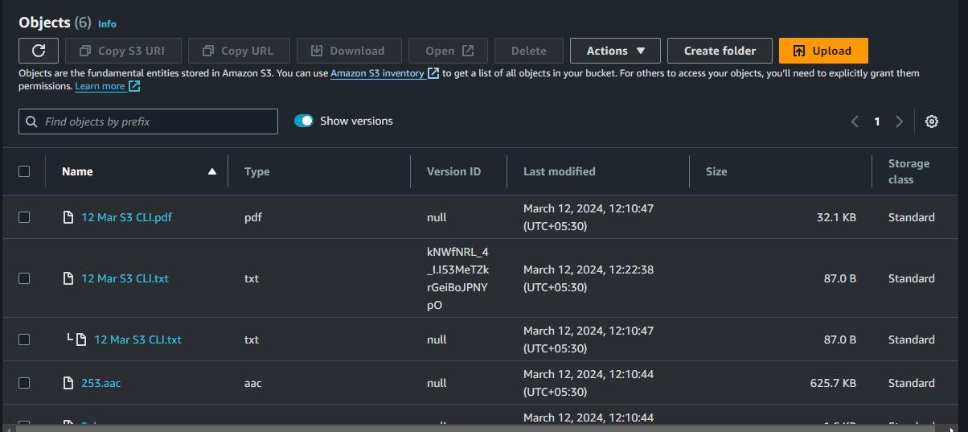After Enable it will Visible Versioning Option and Button and Also we can I Upload Same File its not overwritten Because of Enabled Version so Its New Version for newly added File and old one was null because on that time we are not enable it versioning. So Versioning works

Now Assignment Task-2 Completed

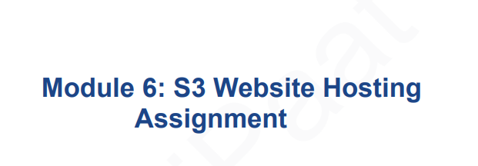

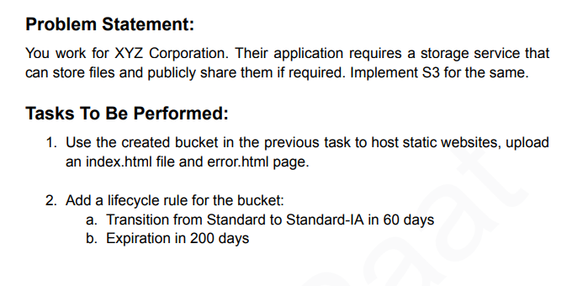

1. Uploaded html file which name as index.html and error.html

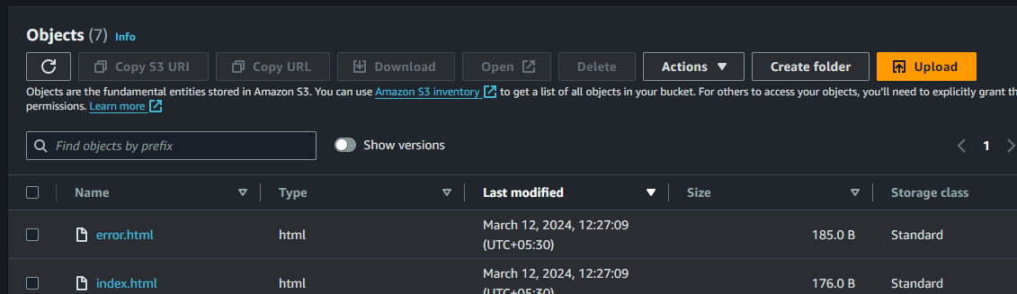

1. Now Go to Properties



1. Scroll down in the last we find static website hosting and click on edit

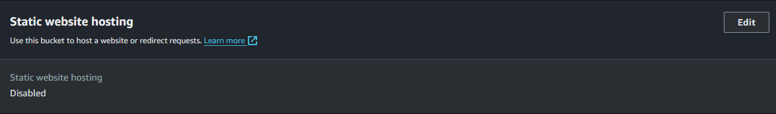

1. Its Disable so enable it.

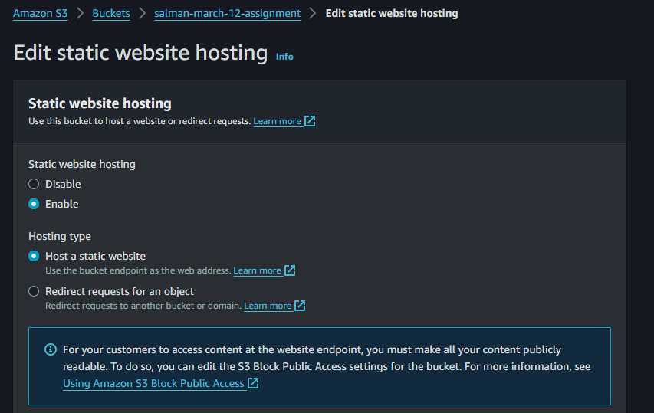

1. Upload static file which as index.html and upload error file if url is wrong then triggered that error file which I have uploaded

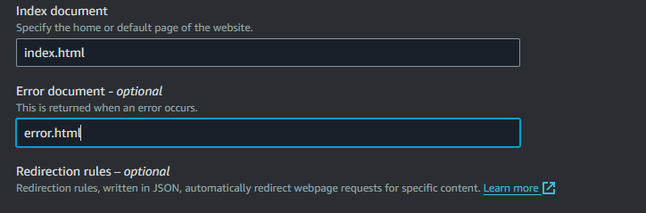

1. Click Save Changes



1. Now Copy the URL

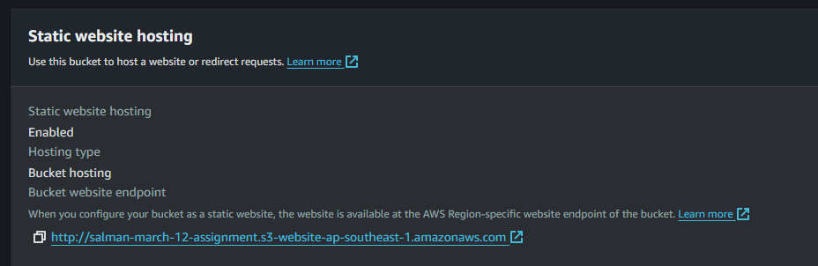

1. Its showing error Because we are not given public Access

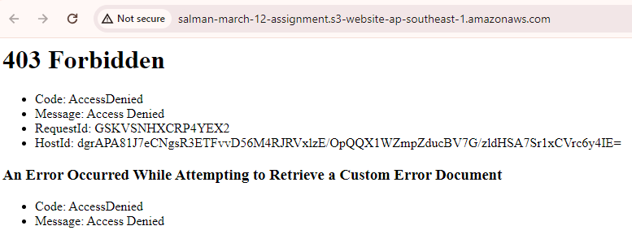

1. We Removed the Block all Public Access and click save changes.

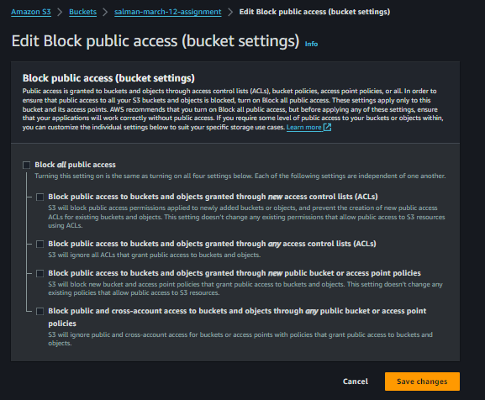

1. Showing Again Same Error Because We have gave access to Bucket not the Objects Ownerships



1. Again go to Permissions

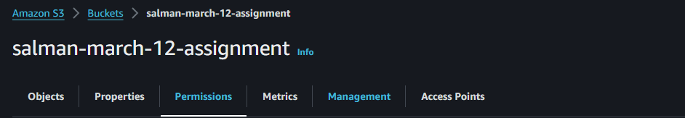

1. Scroll down and u will find Object Ownership and Click Edit

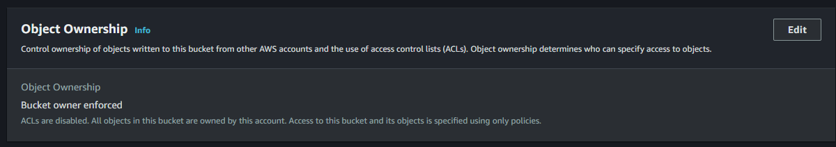

1. Enable ACLs(Access Control Lists) and Save Changes

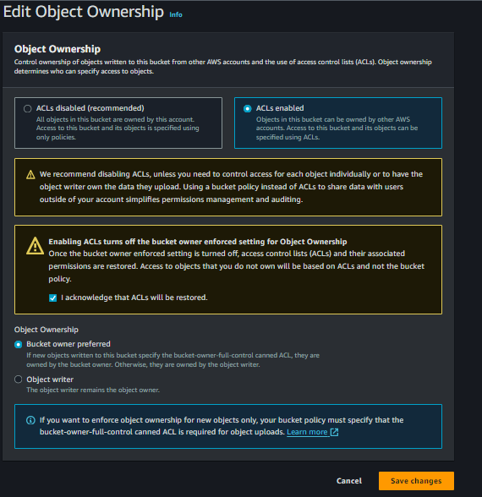

1. Now Select index and error html file and go to Actions and u will find Make Public Using ACL

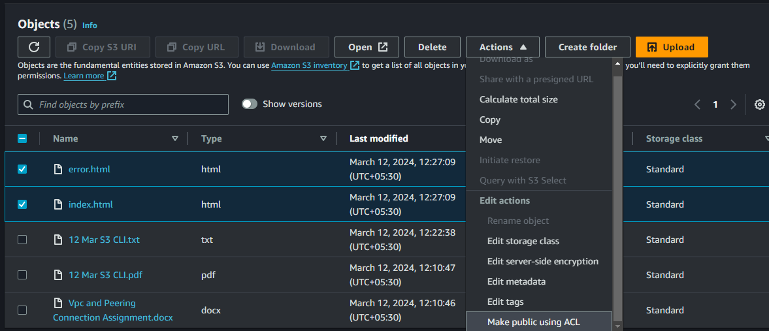

1. And Click Make Public

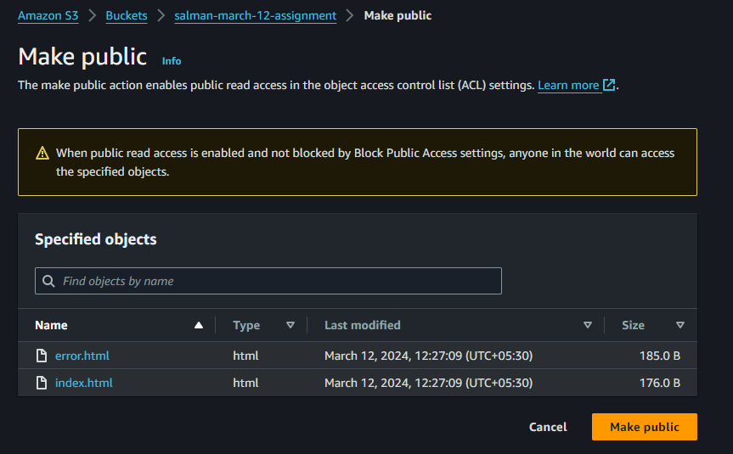

1. Now Again go to Static Website Hosting Click Url and Now u able to see your website



1. Our Static Website Open Successfully

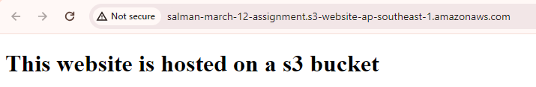

1. After adding another thing in URL and search then its triggered Error.html Page Because we have Uploaded that too if any one change url then show that error page

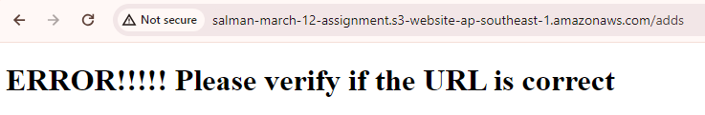

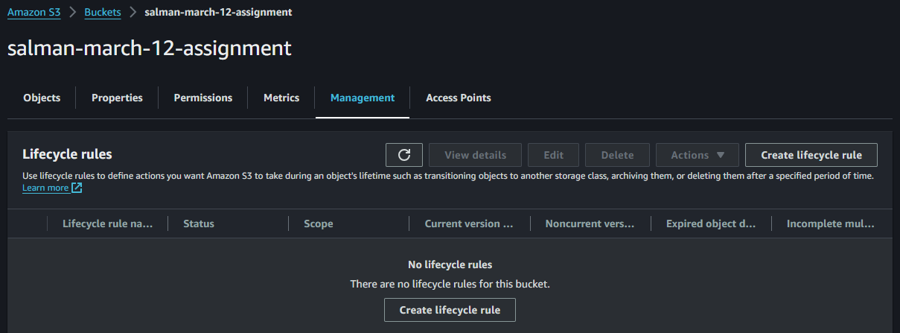

1. Now Second Step Go Management and Create Lifecycle Rule
2. I Currently Selectly All Objects in the Bucket and Click Acknowledge

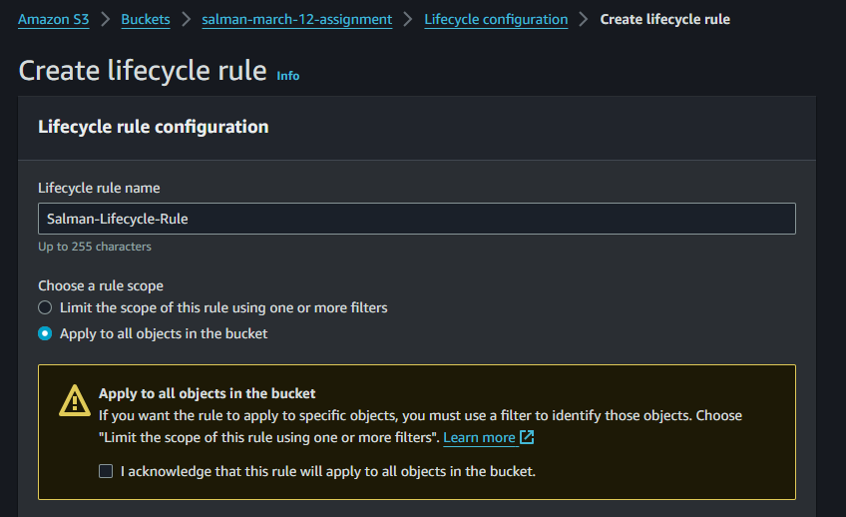

1. As Per Assignment We need to Select Move CV to Objects b/w SC and EC Versions of Objects

And Select Standard-1A and 60 days

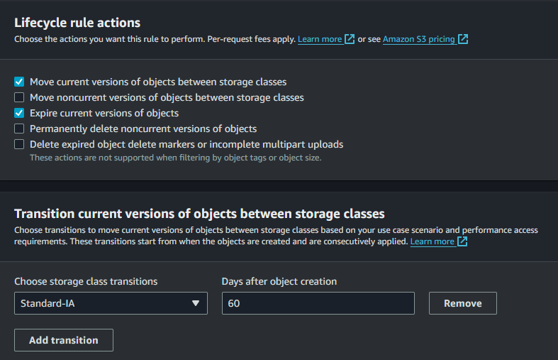

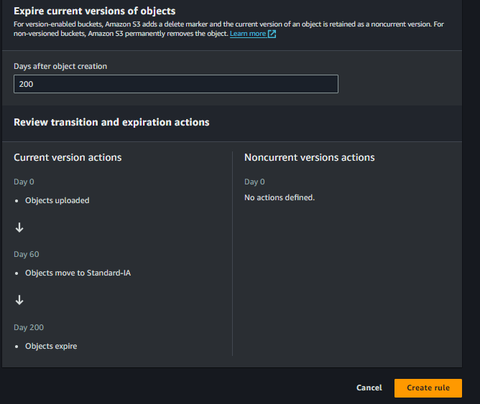

1. And Expiration in 200 Days and Tree Also able To See.

**Thank You**